Final Report

Contextual Visualization of Magnetic Resonance Angiography (MRA)

Farshad Mogharrabi (u1074636)

Karthik Karanth (u1264749)

# Project Goal

Make a visualization tool to enhance the perception and knowledge gained by viewing intracranial vasculature distribution from magnetic resonance angiograms

# Introduction

## Related Work and Background:

Surgeons use angiography images to understand arterial pathways prior and during surgical procedures. It is an imaging technique based on the contrast of

Angiography images used during surgical procedures commonly lack depth information. Surgeons would just

guess directions based on their experience to guide IV probes into the intended arteries. With this project, we

want to explore different ways of enhancing decision making. To make this more intuitive, we will explore user

interaction to expand the visible region:

User sees slices as in traditional imaging

User clicks on a point of interest

User sees an expanded 3D view around the point of interest

User sees arterial pathways that pass through the chosen point

Then through an iterative design process, we will converged to the most convenient and informative ways to

manipulate and visualize the acquired data.

Example brain MRA from our dataset generated using ParaView: (white threads depict vasculature)

## Our Approach:

# Project Implementation

### User Interface:

Initial work on the user interface has commenced. Currently, it supports loading an MHA image of the brain into a VTK-based Python visualization tool. A slider allows the user to control the slice of the image. The next steps are to incorporate ray casting to figure out the region that the user is interested in and expand upon that.

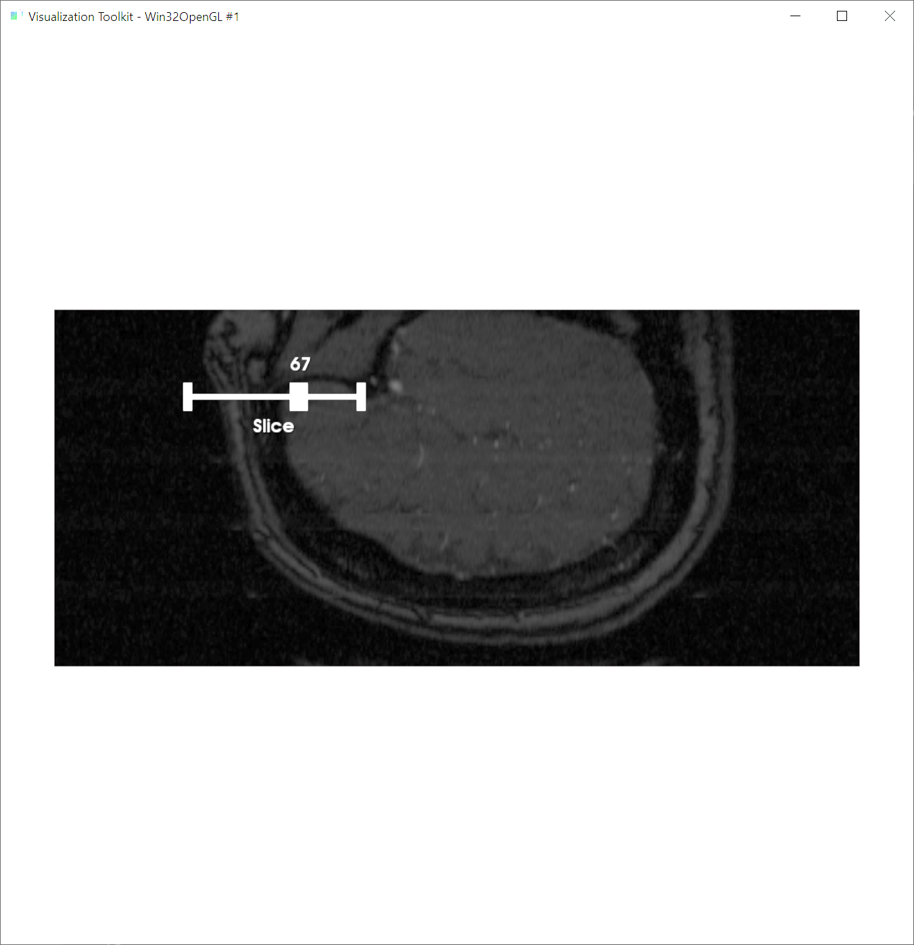

**Figure 1**  our current graphical user interface, capable of changing parameter values over sliders for various filters to be added

### Filtering and processing:

The brain MRA files are scalar fields, and to visualize this data we are using a hybrid combination of slices and volume rendering to best visualize the pattern of distribution of the vasculature. As shown in figure 2, the distribution of values in this type of data is similar to that of many other medical images, with a lot of noise at lower values and then a higher peak for the soft tissue region with a long tail. The blood vessels data resides in the long tail of the histogram, as the blood has distinctive magnetic characteristic compared to other tissues due to high saturation of iron in it. This has been visualized in figure 2 on the right.

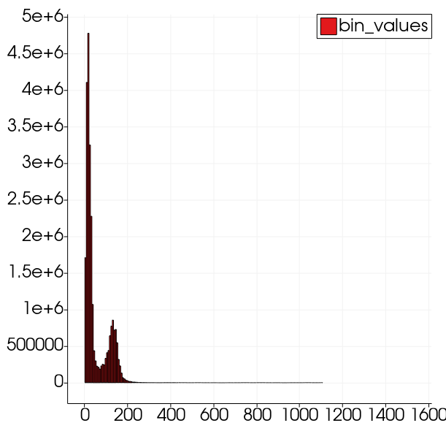 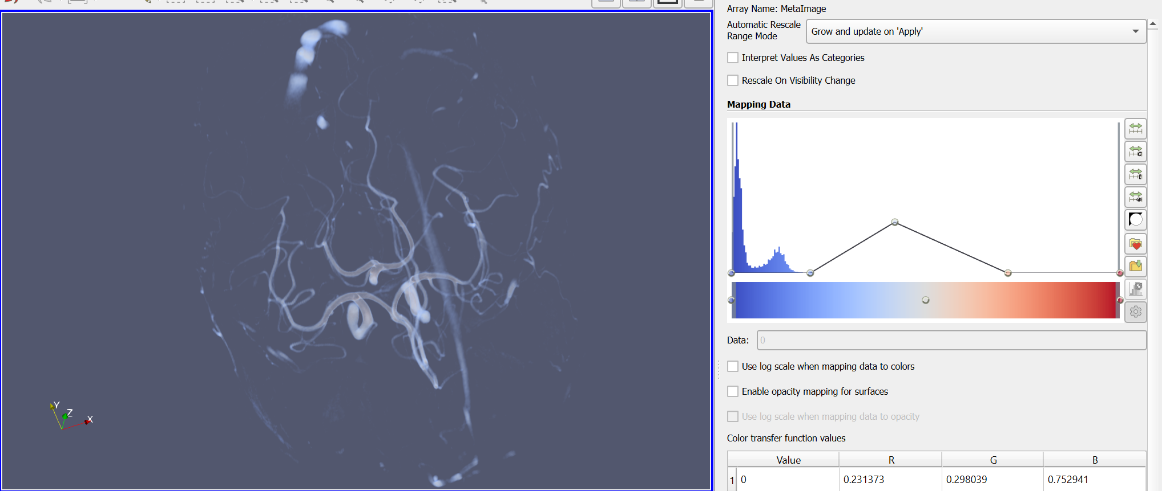

**Figure 2** the data variation of a MRA scalar field visualized (left) and its volume rendering (right)

We now are focusing on extracting the tail region of data in our GUI and show it alongside the slice selected in order to make a 2D-3D hybrid view of the region of interest.

# Steps Toward Completion

**Figure 3** the goal for our visualiztion is to resemble a hybrid view, based on the surgeons opinion

* Adding filters to the GUI
* Adding raycasting to figure out the user’s area of interest
* Using contours to visualize the arterial pathways

We do not expect the above to take significant effort: the main hurdle has been finding good examples/documentation for VTK-python code and we would appreciate any pointers on that.

# Changes Made to The Project Plan

As per the changes in situation regarding meeting with people, and the high work load of medical workers, it is off the table to the university hospital doctor for their feedback on the interface created for evaluating MRA images. However, we are contacting some doctors through online means to get their feedback and iterate through the interface.

# Conclusions and Discussions

To sum up the journey of the project, we started by contemplating the question at hand, “how could we improve how doctors interpret information out of the 2 dimensional representation of a 3D image taken from the patients head?” We learned that the medical community are very acclimated and used to the nature of current representation of the data that does not require much interaction to view on a flat screen except for scrolling through the data; but this single mode of variation in representation does not highlight the features-of-interest within the image. Therefore we decided that combining the familiar older method of visualization of one slice of data at a time, combined with a more modern less utilized method of representing the volume by means of different methods in a hybrid fashion could lead to improved perception and cognition.

Skills learned during the course of the semester, like using interactive widgets, rendering volumetric images and forming isosurfaces within the range of the scalar field values were utilized to achieve this goal.

To keep the simplistic nature of the visualizer and not to overwhelm the user, per the usual minimally modifiable

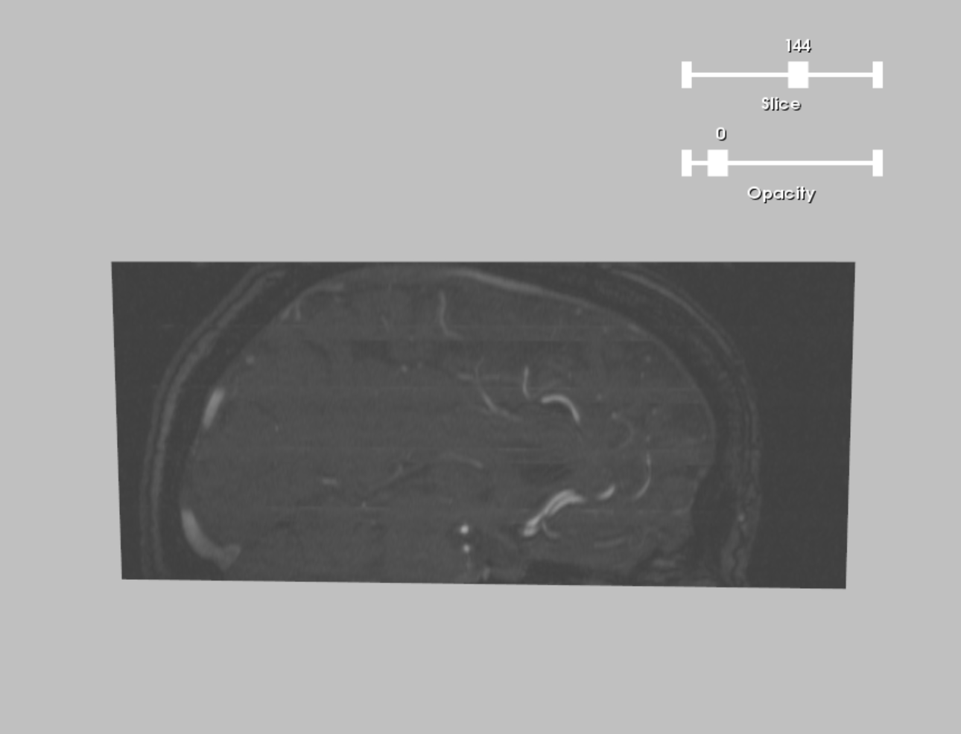

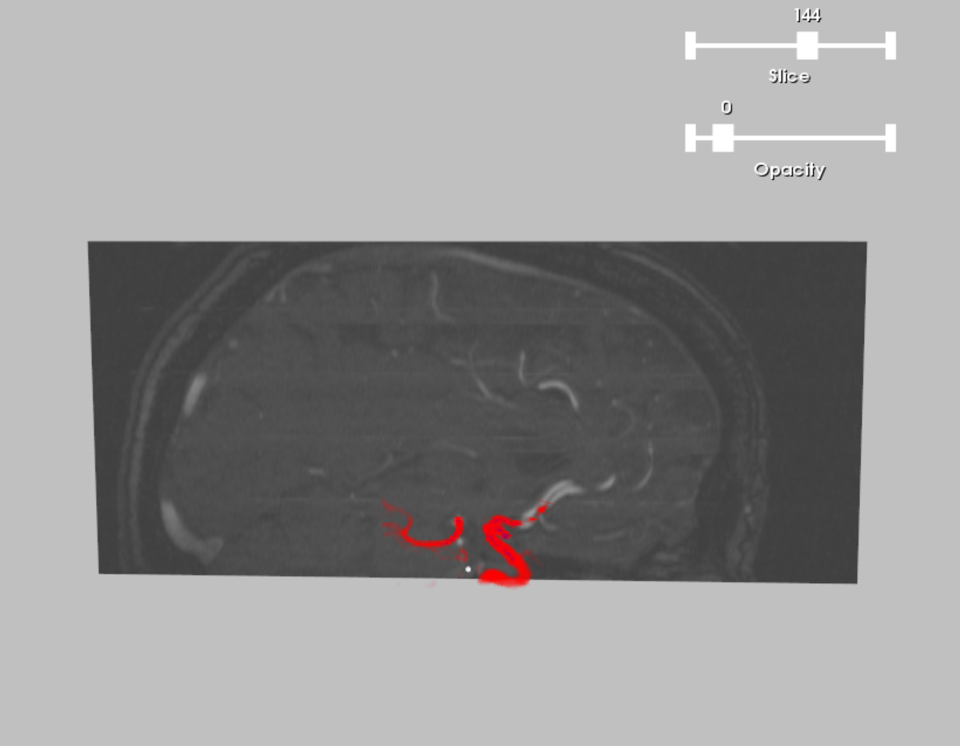

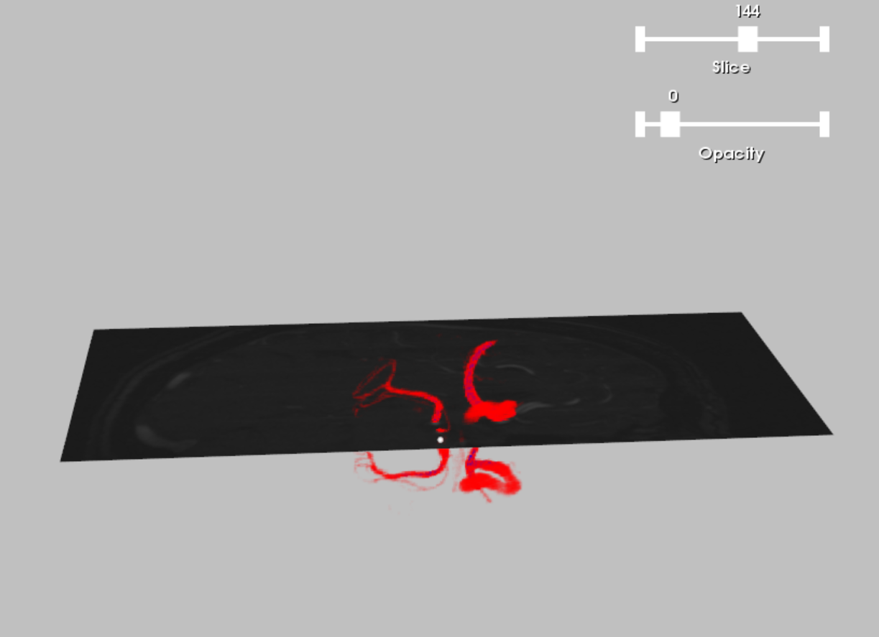

# Work Distribution

# Additional Comments

## References